Welcome to The River Falls Group Home

The team at Positive Alternatives would like to take a moment to welcome you to the River Falls Group Home and provide you with answers to some of the questions you might have. As you find yourself reading this handbook, you may be wondering how you ended up here. It is normal to be feeling angry, scared, sad, or confused. No matter the reason for your stay, you have likely been through a lot and are not quite sure what to expect from your time here. The team at River Falls is here to guide you through this experience. We will work together to create an environment that supports and encourages you to make progress towards your goals.
The River Falls Group Home accepts youth for many different reasons. Your stay may be short, long, or somewhere in between. For the most part, the rules and expectations are the same for all youth. However, everyone is a unique individual with different wants, needs, strengths, interests, and experiences, which may require more individualized treatment and expectations. So, while you are living in the same home and are following similar rules as your peers, another person’s stay might look slightly different. Additionally, if you have specific concerns about your treatment, we encourage you to have a discussion with your case manager, so that we can address these needs.
The purpose of this handbook is to be a reference and learning tool, which outlines the general rules and expectations of the group home. Our goal with creating this handbook is to help you to understand what we do and why we do it, so that you are able to thrive and be successful during your time here. As a team, we believe that it is important to be transparent about our expectations, so that you have a good understanding of what choices and behaviors may lead to different privileges. Additionally, this handbook will outline your rights as a client during your stay at the group home. If at any point you have concerns about how you are being treated by the team or your peers, you are encouraged to speak with your case manager, or a trusted adult, so that we can properly address the situation. As a team, we take pride in being inclusive of all people and we believe that our differences and uniqueness should be celebrated and shared. Additionally, we strive to create an inclusive environment where all people feel valued, respected, and safe.
Change can be challenging, and we understand that the transition to a new placement may be very scary and difficult. During the first couple of weeks, you will receive a lot of new information, have new experiences, and meet new people. We want you to know that our team at River Falls is here to sit in your corner, to be a support and advocate for you along the way. We hope to create a space that helps you to feel safe and comfortable, so that you are able to focus on what you need in order to improve your wellbeing and to meet your goals.

TABLE OF CONTENTS
- Welcome Introduction............................................................................................................pg. 1
- Table of Contents....................................................................................................................pg. 2
- Our Purpose & Values............................................................................................................pg. 3

- Daily Routines........................................................................................................................pg. 4
- Daily Schedule........................................................................................................................pg. 5
- Morning Routine.....................................................................................................................pg. 6
- Bedtime Routine.....................................................................................................................pg. 7
- Medication Administration....................................................................................................pg. 8
- Personal Health & Hygiene....................................................................................................pg. 9
- Room Cleans & Chores..........................................................................................................pg. 10
- Weekend Super Cleans..........................................................................................................pg. 11
- Snack & Mealtimes................................................................................................................pg. 12

- Recreation..............................................................................................................................pg. 13
- Group.....................................................................................................................................pg. 14
- Study Hour............................................................................................................................pg. 15
- Physical Activity...................................................................................................................pg. 16
- Transition..............................................................................................................................pg. 17

- Privileges & Reward Bucks .................................................................................................pg. 18-20
- Electronics............................................................................................................................pg. 21
- Phone & Mail.......................................................................................................................pg. 22
- Treatment Plan.....................................................................................................................pg. 23
- Primaries...............................................................................................................................pg. 24
- Employment..........................................................................................................................pg. 25
- School & Day Treatment......................................................................................................pg. 26
- Sick Policy............................................................................................................................pg. 27

- Personal Belongings.............................................................................................................pg. 28
- Sharing Items & Donations..................................................................................................pg. 29
- Controlled Substance Policy................................................................................................pg. 30
- Physical Boundaries & Restricted Areas.............................................................................pg. 31
- Safety & Respect..................................................................................................................pg. 32
- Supervision & Run Policy....................................................................................................pg. 33

- Youth Rights........................................................................................................................pg. 34
- Grievance Policy..................................................................................................................pg. 35
- Emergency Plan...................................................................................................................pg. 36

OUR PURPOSE & VALUES
Mission
Through a continuum of family and strength-based services, Positive Alternatives strives to equip at-risk youth and young adults with the social, emotional, and developmental skills needed to flourish.

Vision
Positive Alternatives is an innovative resource in Wisconsin for at-risk youth, young adults, and their families by providing creative and collaborative services.
- Acknowledging that youth, families, and the community share the responsibility for preparing children for a successful adulthood, Positive Alternatives strives to equip at-risk youth and young adults with the social, emotional, and developmental skills needed to flourish.
- We are dedicated to empowering those we serve to reach their greatest potential, creating an environment that fosters unity, pride, and resiliency and inspires our community to embrace the strengths of youth.
- Our goal is to provide services that involve the family, focus on the desired outcome, and build on strengths to allow individuals the opportunity to enhance social, emotional, and developmental skills.
Philosophy
Positive Alternatives operates from the belief that individuals and families pass through developmental stages.
- Each stage requires the individuals and/or families to face new tasks and discover alternative adaptive techniques. Successful adaptation at any one stage depends greatly on the individual and family’s ability to master the skills required in the previous stage.
- Behaviors that prove to be problematic are viewed as signals of difficulties mastering the skills associated with the tasks for their stage of development. We recognize the unique task associated with the developmental stages involving youth.

Through Positive Alternative’s philosophy and mission statement, each program’s purpose is reflected and maintained for the youth and families that we serve.
CLIENT CENTERED
CONSCIENTIOUS
COMMUNITY ORIENTED

COMPASSIONATE
COLLABORATIVE
DAILY ROUTINES
One of the first things that you may be wondering, is what your typical day will look like. As a team, we believe that structure and consistency are important factors that will help you to predict what your days will be like. Along with this, we believe that it is important to learn the benefits of being flexible and being comfortable with change. So, while most days will be consistent and look the same, there will be times when different activities will be switched around or excused for that day, due to appointments, visits, long recreation events, and the personal needs of the group. When changes need to be made to the daily schedule, the team will make it a priority to communicate this to you as soon as possible.
The day and its events are broken up into morning and evening. Throughout the day, youth are encouraged to engage in different aspects of programming (study hour, groups, recreation) along with completing daily routines (eating meals, hygiene, room cleans, chores, free time). As a team we believe that it is important to learn and build time management skills. Due to this, we allow for flexibility during our scheduled daily routines (morning, lunch, dinner, bedtime) to provide you with the freedom to use and manage this time as you would like. Below is a list of tasks that are to be completed during different routine times throughout the day:
Morning  Room Clean  Hygiene  Eat Breakfast  Chore | Lunch  Eat Lunch  Chore | Dinner  Eat Dinner  Chore | Bedtime  Snack  Room Clean  Hygiene  Chore

Free Time
Once all tasks are competed for that routine, all remaining routine time can be used as a free period where you can choose to engage in a variety of activities. Some of these activities include, making phone calls, napping, watching tv, playing the Wii, baking, socializing with peers, playing a board game, painting, using an iPad/surface, listening to music, working on homework, having a 1:1 with the team, etc. It is important to note that activity options are dependent on behaviors and choices made during that day. Additionally, it is your responsibility to make sure that you are ready for the next scheduled activity and that all items have been picked up and put away once you are done with them.
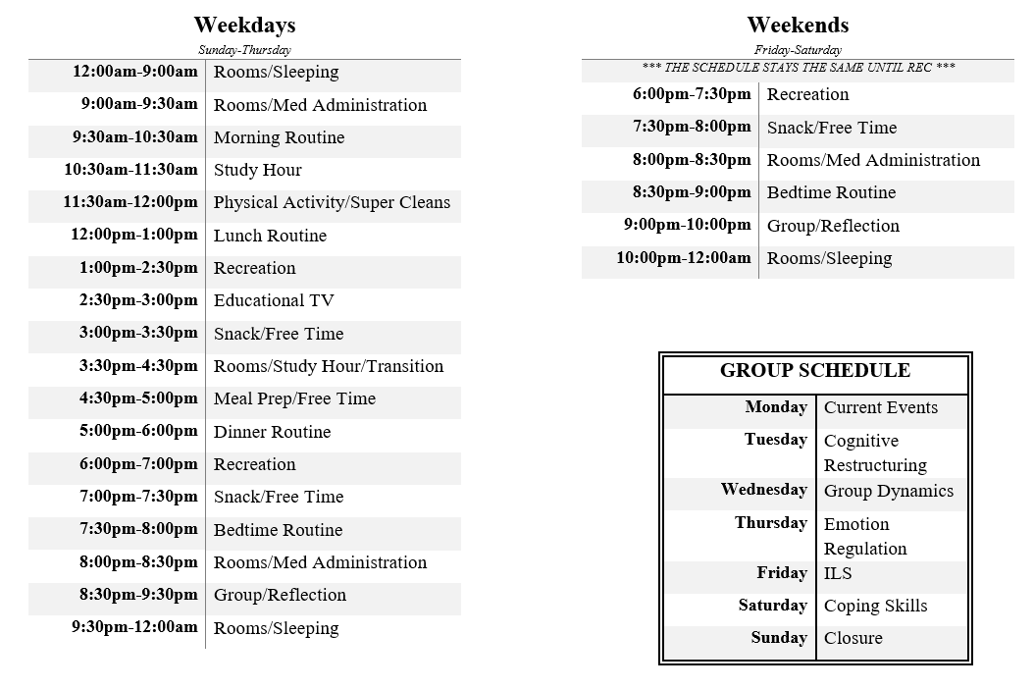
DAILY SCHEDULE
*** The group schedule will change quarterly ***
MORNING ROUTINE
- Wake up times during the school year will vary based on what time the school bus or day treatment transport van arrive at the house. Additionally, morning routines will look different during the school week, when compared to the weekends and summer.
- During the school week, youth are woken up an hour before they need to leave for school, day treatment, and other appointments. If you are concerned about an hour not being enough time to get ready, we encourage you to speak with a member of the team about this, so that we can adjust to your needs.
- On the weekends and during summer, youth are woken up at 9am to take their medications and they are able to come out of their bedrooms and start their morning routines at 9:30am. Youth remain in their bedrooms during medication administration to ensure the confidentiality of other youth in the house. In addition, this allows for the med administrator to give their full attention to the medication process, to ensure proper administration.
- During morning routines, youth are expected to eat breakfast and complete their room clean, chore, and hygiene. Once you have completed all required tasks, the remainder of this time can be used as a free period. In addition, youth can sleep in after taking their medications, as long as they allow for enough time to complete their morning routine. This allows for youth to practice their time management skills.
- Youth are able to use reward bucks to wake up 30 minutes early at 8:30am, if they would like. During this time, youth are encouraged to engage in an independent activity.
- Youth are expected to set their own morning alarms, to ensure that they are awake in time to get ready for school, day treatment, or any other appointments.

BEDTIME ROUTINE

- Bedtimes will vary slightly by a half-hour on the weekdays (Sunday – Thursday) and weekends (Friday – Saturday). On weekdays, youth will go to their rooms for the night at 9:30pm and on the weekends it will be 10pm. However, no matter the day of the week, youth will always be in their bedrooms from 8-8:30pm for medication administration.
  - As stated previously, youth remain in their bedrooms during medication administration to ensure the confidentiality of other youth in the house. In addition, this allows for the med administrator to give their full attention to the medication process, to ensure proper administration.
- During bedtime routines, youth are expected to complete their room clean, chore, and hygiene. Once you have completed all required tasks, the remainder of this routine period can be used as a free time.
- Youth are encouraged to clean their bedrooms during med administration time, due to them already being in their rooms. After med administration, the cleanliness of your bedroom will be checked and noted for allowance each night.
- Lights out occurs at 10:00pm on weekdays and 10:30pm on weekends. After lights out, youth are encouraged to put down what ever they are working on to try and fall asleep for the night. Youth are expected to return all controlled items by lights out each evening.
- Youth are able to use reward bucks to stay up 30 minutes late on weeknights (10pm) and they can stay up 1 hour late on the weekends (11pm). During this time, youth are encouraged to engage in an independent activity. The team may not always agree to this request and the answer will depend on youth choices and behaviors from the evening, the general status of the house, and what required tasks may still need to be completed. No more than 2 youth will be allowed to stay up at the same time.
- Youth are encouraged to make all phone calls during snack/free time and bedtime routines, due to calls being discouraged and limited after bedtime. If a phone call at bedtime is requested, you may be encouraged to save your call for the next day, and it is recommended that you have a 1:1 with a team member instead. However, you will not be denied phone calls to important individuals such as your social worker or guardian.
- As a team we understand that bedtime can be challenging for many people. Youth are allowed to sleep on the living room couch if requested. However, this should only be a temporary fix and youth are encouraged to talk with the team and their case manager to help find a long term solution for this. We can accommodate your needs by allowing you to sleep with your door open, providing you with a night light, allowing you to use music or a diffuser, etc.
  - During overnights, there are many different tasks that must be completed, which ensure the smooth functioning of the house. These tasks include cleaning, inventory, filing, etc. As a result, sleeping in the living room can prove to be challenging for both the youth and team member, due to lights needing to stay on and there being loud movement throughout the house.

MEDICATION ADMINISTRATION
- As a team we understand the importance of proper medication administration to both your physical and mental health. We know that this is an important process that requires focus and concentration, which has proven to be difficult when there is movement throughout the house. Due to this, youth are expected to stay in their bedrooms during this time (9-9:30am & 8-8:30pm). In addition to ensuring proper administration, this procedure also allows for maintaining the confidentiality of youth treatment and medical information.
- All medications will be kept in the RC office, and they will be available to you at their prescribed or requested times. Additionally, medications are always administered by a team member. Medication administration occurs during both morning and bedtime routines. It is also possible for additional medications to be prescribed at various times throughout the day, depending on your needs. Lastly, over the counter medications (Tums, Tylenol, ibuprofen, etc.) are available upon request.
- All medications will be prescribed by your doctor, and you will receive regular doctor’s visits throughout your stay. Additionally, you will have the ability to request doctor’s visits as needed, to discuss your physical or mental health needs.
Expectations
- Youth are required to take their medications with water, without ice, and in a clear cup, unless otherwise specified by your doctor. Additionally, youth are required to drink the entire glass of water when taking their medications.
- During medication administration, you will be asked to roll up your sleeves and to not have a blanket on or wrapped around you, at the time. Additionally, the med administrator will ask you to conduct routine mouth checks, after you have received your medication.
- Medications should always be administered at the RC office doorway, to ensure proper administration with minimized distractions and to promote confidentiality of treatment and medical information.
- An important part of our wellness is knowing and understanding what medications we take and the purpose for them. As a result, before you take your medications, the med administrator will ask you what it is that you are taking. The team and your case manager are available to help you better understand what medications you have been prescribed.
Discontinuing Medications
- All youth have the right to choose to not take their medications. In this situation, the med administrator will facilitate a discussion with you about your reasoning for not wanting to take your medications and they will inform you of the potential negative side effects of stopping your medications all at once. They may also explain the importance of taking medications consistently for them to work in an effective manner. Lastly, they will encourage you to talk with your treatment team and doctor about your interest in stopping or changing your medications.
- If you are interested in discontinuing your medications, your case manager can help to set up a doctor’s visit for you. This will allow you with the opportunity to speak with a medical professional about either, finding a different medication that may be a better fit for you, or learning how to properly discontinue your medications in a way that is not harmful to your physical or mental health.
PERSONAL HEALTH & HYGIENE
Maintaining good personal hygiene is an essential factor when it comes to one’s physical and mental well-being. As a team, we believe that it is important to develop regular hygiene routines that can be practiced daily to maintain good health. Personal hygiene is a broad term that encompasses a variety of practices including, washing your hands, brushing your hair, cleaning your face, brushing and flossing your teeth, bathing/showering, using soap and deodorant, regularly washing your clothes and bedding, etc.
There are built in times during the day where youth are expected to practice their personal hygiene. Youth are encouraged to shower daily and to focus on general hygiene in the morning and evenings. Each youth will be assigned a designated shower time, which will be staggered either in the morning or evening. The purpose of this is to ensure that everyone is provided with an adequate amount of time to complete their routine. Youth are also able to shower during free periods throughout the day, or during self-care activities. Additionally, youth are encouraged to keep their shower times to 15 minutes, to ensure that everyone will have a chance to complete their routine. While in the bathroom, a team member may knock on the door to verbally check in with you and ensure that you are okay. If we do not receive verbal confirmation that you are okay, we may need to enter the bathroom to confirm your safety.
During your stay, you will be provided with basic hygiene essentials, and you will have the opportunity to purchase preferred items at the store, if you would like. All hygiene products will be kept in a locked storage space and will be available during appropriate times when requested. Youth are expected to return their hygiene products after their use. Additionally, youth are able to use razors and shave, as long as there is no current safety risk present. Youth will be assigned a specific time when they can use their razor throughout the week, to ensure safety. When using a razor, you will be expected to return this item immediately after its use.
Each youth will be assigned a bathroom that they will use during their stay. Youth are encouraged to respect the boundaries of their peers, by only using their assigned bathroom. Additionally, only one youth is to be in the bathroom at a time. Due to the bathroom being a shared space, it is your responsibility to keep it clean and dry after each use and to put away all personal belongings. Lastly, when using any heating tools (straightener, curling iron, hair dryer, etc.), youth are expected to leave the bathroom door open.
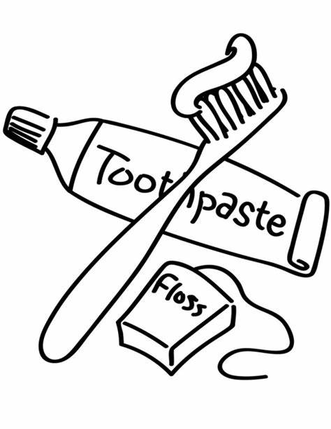
Another important factor to maintaining good hygiene is regularly cleaning your clothes and bedding. During your stay, you will be provided with detergent and drier sheets to clean your laundry. If you have any specific allergies or needs for sensitive skin, please communicate this to the team. Each youth will have a designated day of the week where they will have the opportunity to use the laundry room. If there is a day that is not assigned to a specific person, youth are able to take advantage of this time to do their laundry. Only one youth should use and be in the laundry room at a time and youth are not able to mix their laundry with their peers. Youth are encouraged to focus on their time management skills by keeping up on this task throughout the day, so that all personal laundry is washed and out of the laundry room by bedtime. This is encouraged so that all house laundry, such as towels and bedding, can be washed overnight. It is your responsibility to ensure that the laundry room is kept clean and tidy after you have used it.

ROOM CLEANS & CHORES
An important part of our wellness includes the cleanliness of the environment that we live in. Living in a clean space can help to improve our physical and mental health, by reducing stress and anxiety levels, improving sleep, getting rid of harmful bacteria/germs, decreasing allergens, and warding off unwanted pests. Due to this, as a team we believe that it is essential to help develop regular cleaning routines. During your stay, you will be expected to help maintain a clean home through daily room cleans and chores.
Each youth will be given a weekly chore, where they will be responsible for maintaining the cleanliness of that section of the home throughout the week. There are 7 different chores that are rotated amongst the youth monthly, these include 1. Living, Laundry, and Chill Room; 2. Kitchen, Entryways, and Dining Room; 3. Dishes; 4. Meal Prep and Garbage; 5. Bathroom (Room 1 and 2); 6. Bathroom (Room 3 and 4); and 7. Chore Leader. How often each youth is assigned a certain chore, will be dependent upon how many people are staying at the house at the time. Each of these chores have been carefully designed so that they all involve a relatively equal amount of effort when compared to each other. For all chores, there are more responsibilities during dinner routines, and there are fewer responsibilities during morning, lunch, and bedtime routines. Youth are encouraged to ask for help from the team and their peers when needed, we believe that it is important to work together to maintain a clean house.
In addition to helping maintain the cleanliness of common areas, youth are also responsible for ensuring that their rooms are clean every morning and evening. Some general standards for having a clean room include, making your bed, throwing away all trash, returning controlled items, putting away clothes, and organizing belongings, so that the floor space is clear.
Additionally, youth are encouraged to pick up after themselves throughout the day to ensure that all personal belongings are either in their bedroom, or in a storage space. Youth are expected to return all controlled items before transition periods, either in the afternoon or evening before going to bed. Similarly, youth are expected to put away all personal belongings before these transition periods, and all items left out will be placed in the lost and found. To retrieve an item from the lost and found, a youth must complete one verbal positive affirmation about themselves (ex. I am kind, I am strong, I am a good friend, I am a hard worker, etc.). These responsibilities are in place to help build regular practices that allow for keeping a decluttered home and the ability to keep track of one’s belongings. During Saturday room cleans, youth can collect all items from the lost and found, without the requirement of stating positive affirmations.
Youth will have the opportunity to earn allowance 6 times a day, by completing their daily chores and room cleans (AM Room Clean, AM Chore, Lunch Chore, PM Room Clean, PM Chore, Bedtime Chore). As a team, we believe that the power of making choices and decisions for oneself is an essential part of maintaining one’s wellbeing. Due to this, you will not be forced to complete tasks or engage in activities if you do not wish to do so. While this is true, all choices that we make have outcomes that may be viewed as positive or negative. So, while you have the choice to not complete your chores, it is important to understand that you will also be choosing to not earn allowance for this task. Additionally, if you choose to complete extra cleaning tasks throughout the day, you will be given the opportunity to earn reward bucks, which can be used to purchase snacks, stay up late, have extra electronics time, etc.

WEEKEND SUPER CLEANS

Bedrooms
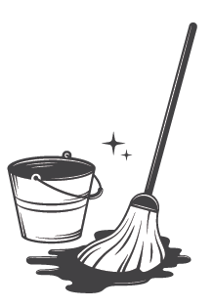
Bedroom super cleans are completed once a week on Saturday mornings, during physical activity. This time is an opportunity for the youth to focus on deep cleaning their rooms. If a youth is consistently gone during the weekends, they may be encouraged to complete this task before they leave. During room super cleans, youth are encouraged to:
- Pick up all items off the floor, including underneath the bed and in the closet
- Organize and put away all belongings
- Turn in all controlled items
- Straighten up all items in the closet
- Neatly fold and put away all clothing into drawers and on shelves
- Place dirty clothes and towels in your laundry basket
- Ensure that all wet bath towels are hung up, either on your closet hook or in the bathroom, to properly dry
- Sanitize the outside of the closet dresser and bedside table
- Sanitize bedroom light switch and door handles
- Wash bedroom window and windowsill
- Throw away all trash and empty the trash bin, if needed
- Vacuum all carpeted area, including the closet and under the bed
- Ensure that you have all bedding on your bed (or in your bedroom). This includes a mattress pad, fitted sheet, flat sheet, blanket, comforter, 2 pillowcases, and 2 pillows
- Neatly make the bed

During room cleans, everyone will be given the opportunity to go through and organize their belongings in the storage room. Each youth is encouraged to arrange all their items, so that they neatly fit in a single drawer. Additionally, youth will be given the chance to go through the lost and found and collect their belongings. Youth are not required to complete positive affirmations during this time to receive their items.
Common Areas
Common area super cleans are completed once a week on Sunday mornings, during physical activity. This time provides the opportunity for different areas of the house to receive a more thorough deep clean. Youth will receive allowance for completing these chores. Certain tasks may be assigned more frequently, depending on the specific needs of the house. Similar to the daily chores, these have also been carefully designed so that they all involve a relatively equal amount of effort when compared to each other. Each youth will be given one chore to complete during this time. The different super clean chores include:

Bathroom (RM 1 & 2) Fridge/Freezer Shovel & Salting the Front Yard
Bathroom (RM 3 & 4) Appliances Shovel & Salting the Back Yard
Kitchen Furniture Windows Kitchen Cupboards & Drawers
Deep Clean Equinox Front Yard Garage & Front of the House
Deep Clean Van Back Yard Garbage & Recycling
Walls & Cupboards Rec Closet Laundry & Chill Room
Living Room

SNACK & MEALTIMES
Weekly Menu
- There are three mealtimes scheduled throughout the day (breakfast, lunch, and dinner) and two snack times (afternoon and bedtime).
- The team develops the weekly menu with the intention of teaching and creating balanced and healthy eating patterns. Due to this, youth are encouraged to prepare all items listed on the menu for each meal.
- Youth are encouraged to communicate with the team about different meals and snacks that they would be interested in seeing on future menus.
- If you are not interested in eating the scheduled items for that mealtime, there are a variety of substitute options available for you to choose from. If you choose this option, you are expected to clean and put away all items used to make your personal food. A list of alternative meal/snack items is posted on the fridge. Youth are also able to use reward bucks to purchase additional meal alternatives as well.
Mealtimes
- Meal prep is a task that is assigned daily to a youth. The purpose of this chore is to help you learn how to make different types of meals, develop independent living skills, and build a sense of community with your peers. If you are assigned to complete this task, you are expected to make dinner and help to prepare snack. When competing this task, you are highly encouraged to ask for help, as needed.
- Dinner will be eaten family style, with the table fully set with plates, silverware, and the food, which will be passed around during the start of the meal. Youth are expected to ask to be excused after eating.
- After everyone has dished up their food for dinner, there will be a 30 second moment of silence that everyone is encouraged to participate in before eating. The purpose of this is to provide youth with the opportunity to pray or express gratitude if they would like.
- Everyone is expected to sit together at the dinner table for a minimum of 20 minutes. This is a time where everyone can catch up and discuss their day with peers. Additionally, this time will allow for a discussion about what the remainder of the day will look like and what planned activities are scheduled.
- Everyone is encouraged to have appropriate conversations and manners during mealtimes. This may look like, not speaking with your mouth full, no throwing dishes or food, asking to be excused after eating, cleaning up after yourself, etc.
- Youth are encouraged to have 1 serving of a fruit or vegetable before they can have a second serving of the main dish.
- All youth will be assigned a specific color of dishware that they will use during their stay. After eating, youth are expected to scrape off their personal dishes and rinse them, before loading them into the dishwasher. Youth are encouraged to handwash their silverware and return to a team member after eating; please do not place these items in the dishwasher.
- After all routine tasks and chores are completed, the remainder of this time can be utilized as free time.
Snack
- All youth are given one snack item during the morning and evening. Youth can purchase additional snack items, up to 2 extra during each time of day, using reward bucks.
- Youth are encouraged to wait to eat until designated snack and mealtimes. Youth are allowed to eat their personal food items during meal and snack times and are encouraged to make healthy decisions.
- Youth are able to have one caffeinated beverage per day, before 3:30pm.
- All food and drinks are to be kept on tiled spaces in the kitchen and youth are encouraged to only bring water into the living room or bedrooms. The purpose of this is to promote the cleanliness of the home and to prevent unwanted pests.
RECREATION
Recreation is a time for youth to participate in activities that they enjoy. Different activities will be scheduled for every morning and evening throughout the week. The choices and behaviors of the youth will impact what activities they may engage in for that day. Moreover, not following expectations may lead to their privileges being paused. Recreation is an opportunity for youth to develop relationships with peers by sharing fun experiences, exploring new places, and discovering new interests together. Youth are encouraged to be making connections with their peers while engaging in rec activities, and phone calls are discouraged and limited during this time. Youth are encouraged to communicate with the team about their personal interests and hobbies, so that we can plan recreations that you are excited about and look forward to. Recreation will include a variety of activities, including:
Physical Activity- This is a time when you will be able to get up and be active. Examples include sports, hikes, swimming, and visiting the YMCA.
Arts & Crafts- This time will offer you the opportunity to be creative and learn new ways to express yourself. Examples include painting, making slime, and tie dying t-shirts.
Cultural Events- These activities allow you to stay connected to your identity and learn about others. Examples include festivals, museums, and other special services.
Community Events- These events will help you to build connections with different people and create a greater sense of belonging. Examples include River Falls Days, school activities, sporting events, and the Minnesota State Fair.
Community Service- This time provides you with the opportunity to give back to the community. Examples include Feed My Starving Children and Crowing Achievements. The time you spend participating in these activities may also be used to fulfil court-ordered community service hours.
On Grounds- These activities are scheduled at the group home. Examples include board games, movies, bonfires, and baking. At times, due to weather or other factors, off grounds recreations may need to be cancelled and replaced with an on grounds option.
Off Grounds- These activities will be out in the community and may take place in River Falls or nearby communities like Hudson, Woodbury, or the Twin Cities. Examples include the Science Museum, MOA, beaches, and professional sporting events. While off grounds, youth are expected to stay with the group, and they are not allowed to walk off on their own. If youth require significant redirection while on rec, their off grounds privileges may be temporarily paused, until they can show improved choices and behaviors.
GROUP
Group is a therapeutic activity designed to provide you with an opportunity to learn, grow, and share things about yourself with others. The purpose of group is to provide you with something new. This may include learning new information, building a new skill, having a new experience, or developing a new understanding. Groups also allow you to make connections, give and receive peer support, appropriately share past experiences, and teach and learn from your peers. Phone calls are discouraged and limited during this time and youth are instead encouraged to make phone calls during their routine and free times throughout the day.
Groups can prove to be a very meaningful and vulnerable time for many individuals. Due to this, there are different guidelines that everyone is expected to follow in order to be respectful of others, their experiences, and treatment. An important piece of group is that everything discussed must remain confidential, to ensure the privacy of that individual and to help build trust. During group you will be encouraged to contribute to the discussion, share your thoughts, feelings, and experiences, to a level where you are comfortable, express conflicts and concerns, offer suggestions, etc. Additionally, everyone is expected to treat each other in a respectful manner by being on time, refraining from using disrespectful language that is targeted towards another, and not interrupting those who are speaking. Lastly, it is important to remember that group is in place with the purpose of being beneficial to you and your wellbeing/treatment. To find meaning in group, it is essential that you show up with an open mind and the understanding that you will get from group what you put into it.
Groups occur once a day in the evenings before bedtime. It is encouraged that you talk with the team about group topics that you are interested in learning more about and that may be beneficial to your treatment and improving your wellbeing. Groups will cover a variety of topics, including:
Alcohol and Other Drug Abuse (AODA): This group will offer educational information on AODA issues. Topics will include categories of drugs, signs of abuse, and legal consequences.
Corrective Thinking: It is important to learn healthy ways to cope with past experiences. This group will help you understand how you think and make choices, and it will help you adjust this in a healthy manner.
Independent Living Skills: This group will teach about valuable skills for how to be successful in adulthood. During this group, you will learn about budgeting, balanced eating, applying for jobs, etc.
Interpersonal Skills: It is important to identify that we are members of a community and our choices impact those around us. This group will teach you how to effectively interact and communicate with others.
Healthy Relationships: This is a group that teaches youth how to develop healthy relationships, set boundaries, and identify unhealthy patterns in relationships.
Closure: Being mindful of our goals helps us to stay focused and achieve more. This group provides time to evaluate your weekly progress on your treatment goals and identify strategies and barriers to success.

STUDY HOUR
Study Hour is designed to provide you with time to work productively and independently in a quiet environment. Study Hour takes place in both the morning and evenings. Morning study hour can be completed either in common areas or your bedroom. Evening study hour occurs during transition, and youth are expected to be in their rooms for the entire hour. This helps to ensure that all information about those living in the home is kept confidential and private during transitions and team meetings. Music with headphones is allowed to be used during study hour. The music must be at an appropriate volume that does not disturb others. If music becomes an issue at any time, the team may pause this privilege.
Youth are encouraged to decide on an activity and gather all needed materials before study hour begins. During study hour you will be expected to work on an activity that is both productive and independent from your peers. Additionally, phone calls are discouraged and limited during this time and youth are instead encouraged to make phone calls during their routine and free times throughout the day. Youth are encouraged to prioritize completing time sensitive activities first, such as homework. Activities that may be completed during this time include:

OPTIONAL STUDY HOUR ACTIVITIES

Educational/ Treatment Focus | Self-Care | Creative | Physical Activity
Reading | Hygiene | Coloring | Walk on the treadmill
Homework | Make Up | Journaling | Yoga
Phase Worksheets | Painting your nails | Baking | Circuit workout
Word puzzles (crossword puzzles, sudoku, word finds) | Clean bedroom | Make bracelets | Chores

PHYSICAL ACTIVITY
Physical activity occurs for 30 minutes each morning from 11:30am – l2pm. Throughout the week (Monday – Friday) different exercise activities may be completed during this time. Whereas on the weekends (Saturday – Sunday) super cleans of the bedrooms and common areas will be completed. Physical activity provides the youth with an opportunity to move their bodies and get some exercise in. Some physical activity options include:

- Yoga
- Zumba
- Stretching
- Neighborhood walks
- Walking on the treadmill
- Workout videos
- Learning dances
- Cleaning tasks or yard work
- Wii sports or Just Dance
- Completing a workout or dance routine
- Create obstacle courses
- Create circuits (ex: 10 jumping jacks, 10 push-ups, 10 lunges, 60 second break, then repeat)
- Have a dance party
- Frisbee
- Playing catch
- Playing yard games
- Playing basketball
- Kicking around a soccer ball
- Jump rope
- Swimming

TRANSITION
Transition periods are an important part of the daily schedule, and they occur a few times throughout the day when different team members are coming and going. Transitions provide space for the team to communicate with each other about important information. This time is essential for helping to ensure the smooth functioning of the household. Some topics that may be discussed include:
- The general state and mood of the whole group.
- An individual review of each youth, which may include how their day has been and any upcoming appointments that must be attended.
- Information on any unfinished tasks that need to be completed.
- The schedule for the remainder of the day, including information about recreation and group activities.

While transition is taking place, youth will be expected to stay in their bedrooms and a sound machine will be in use. These procedures will help to ensure the confidentiality of treatment information regarding all individuals in the home. It is encouraged that everyone completes all necessary tasks before transition periods occur. This includes, returning controlled items, using the bathroom, and collecting all items that you want to use during this time (pencil, mp3 player, coloring materials, homework, etc.). Additionally, youth are encouraged to make all phone calls during routine and snack times. Calls are limited and discouraged during transitions, due to the importance of maintaining the confidentiality of others.
Transition periods will occur during the morning (6:45am-7:15am), afternoon (3:30pm-4:30pm), and night (11:45pm-12:15am). Youth will likely be sleeping in their bedrooms during both the morning and night transitions and will not be affected by this exchange. During the afternoon transition, youth will participate in their evening study hour in their bedrooms.

PRIVILEGES & REWARD BUCKS

During your stay, there will be a variety of different privileges that you will be offered. Some of which include, using electronics, staying up late, earning reward bucks, going on off-grounds recs, and purchasing items from the prize bin. These privileges will be earned and paused based on your daily choices and behaviors. Certain privileges may be paused until necessary tasks have been completed.

Reward Bucks
- The purpose of reward bucks is to highlight your positive behaviors and choices. They are also in place to help you recognize your own treatment progress. Reward bucks are awarded for doing positive things, such as participation in programing, completion of tasks and chores, school engagement, completing extra tasks around the house, and making notable treatment progress.
- Youth are able to earn reward bucks when their privileges are paused, however, you cannot spend reward bucks when privileges are paused. You may not use or transfer your reward bucks to another individual in the home and doing so may result in your privileges being paused.
- Youth will be in charge of keeping track of their reward bucks and deciding on a storage method for them. There are available storage areas around the house that are locked, if this is your preferred way of keeping track of your reward bucks. You are also able to keep these in your bedroom with you.

- Ways to earn reward bucks include:
  - Programming
    - Participating in all scheduled activities and completing all required tasks throughout the day. You have the opportunity to earn $100 reward bucks twice a day during the morning and evening, if you completed and engaged in all scheduled parts of programming. If you do not complete or participate in one aspect of programming (ex. not participating in physical activity), you will not earn your reward bucks for that time period. However, you are still able to work towards earning reward bucks during the evening, even if you did not earn them during the morning. These times of day do not impact each other regarding your reward bucks.
    - Youth can earn a programming bonus of $200 per week for full participation and completion of all tasks for the entire week. If you have full participation throughout the week, you can earn up to $1,600 reward bucks.
  - School
    - As a team we believe that participation and engagement in school is very important. You will have the opportunity to earn $100 reward bucks each week on Sundays if you attend school every day and are passing all your classes. Your grades and attendance will be checked every week to determine your eligibility for earning reward bucks.
    - You will also have the opportunity to earn $100 reward bucks if you have no missing assignments by the end of the week.
  - Treatment Progress
    - You can earn reward bucks for making notable treatment progress anytime throughout the day. If at any time you show significant improvement on your treatment goals, you will be able to earn reward bucks. It is important to remember that everyone has different goals and choices that they are working on improving, and one person going above and beyond in a certain area may be another individuals’ regular choices. To earn reward bucks in this way, you will need to make clear progress in comparison to yourself and your previous choices, and not when compared to your peers. You have the opportunity to earn $100 reward bucks each time you make obvious improvements to your treatment and choices.
  - Group Leader
    - After group each day, the team will identify a youth that acted as a leader during group, and they will have the opportunity to earn $100 reward bucks. To qualify for this, you should be displaying positive social interactions with the team and peers, have high levels of engagement/vulnerability, and show leadership qualities.
  - Random Acts of Kindness
    - Learning how to have positive social interactions with others is highly important to your growth. Youth will have the opportunity to earn $100 reward bucks per am/pm for displaying positive social interactions and being notably kind or helpful to their peers or the team.
  - Completing Extra Chores & Tasks
    - You have the opportunity to earn $100-$200 reward bucks when you choose to help complete extra chores and tasks around the house. Maintaining a clean environment is an important part of maintaining physical and mental well-being and going out of your way to help improve the environment is greatly appreciated.

Below is a chart that outlines how you can earn reward bucks:
Category | Requirement | Amount | How Often | Calculated | Distributed
Full AM Participation | Completed all AM tasks: clean room, AM chore, hygiene, study hour, physical activity, lunch chore, recreation, educational tv | $100 | Daily | During afternoon transition | After transition during free time/meal prep
Full PM Participation | Completed all PM tasks: study hour, PM chore, recreation, bedtime chore, clean room, hygiene, group | $100 | Daily | After bedtime | After bedtime or the next morning
Weekly Participation Bonus | Fully participated in programming and completed all tasks for the entire week | $200 | Weekly | Sunday overnight | Sunday morning
School Participation Bonus | Have no missing assignments by the end of the week | $100 | Weekly | Fridays by the Case Manager | Sunday morning
School Participation Bonus | Attended school every day and are not failing any classes | $100 | Weekly | Fridays by the Case Manager | Sunday morning
Treatment Progress | Showed positive treatment improvement, when compared to oneself | $100 | Staff Discretion | When noticed in the moment | ASAP after noticing the behavior
Group Leader | Displayed positive social interactions, had high levels of engagement/vulnerability, showed leadership qualities | $100 | Staff Discretion  (1 youth per shift) | When noticed in the moment | After group
Random Act of Kindness | Displayed positive social interactions and was notably kind or helpful to others | $100 | Staff Discretion | When noticed in the moment | ASAP after noticing the behavior
Extra Chore Completion | Offered to help complete extra household chores | $100-$200 | Staff Discretion | When noticed in the moment | ASAP after noticing the behavior

Below is a chart that outlines what you can purchase with reward bucks:
Free Time & Programming  Maximum of 2 hours of nonplanned electronic time per am/pm | Item | Requirements | Cost
 | Using the iPad/Surface | Purchase in 30 minute increments  Allowed during free time & after routines | $200
 | Watching TV | Purchase in 30 minute increments  Allowed during free time & after routines | $200
 | Playing the Wii | Purchase in 30 minute increments  Allowed during free time & after routines | $200
 | Staying Up Late | Purchase in 30 minute increments  Sun-Thurs: Can stay up 30 minutes late  Fri-Sat: Can stay up 1 hour late  Approve 1 hour in advance  Must do an independent activity during this time | $200
 | Waking Up Early | Purchase in 30 minute increments  Mon-Fri: Can wake up 30 minutes early  Sat-Sun: Can wake up 1 hour early  Must do an independent activity during this time | $200
 | Neighborhood Walk | Purchase in 15 minute increments  Allowed during free time, after routines & physical activity | $600
 | Change Rec | Approve 2 hours in advance  Changing to an on-grounds option | $600
 | Change Rec | Approve 2 hours in advance  Changing to an off-grounds option | $1,000
 | Store Run Request | Approve 2 hours in advance  1:1 with Staff | $1,400

Snacks & Prizes | Prize Level | Examples | Cost
 | Level 1 | Items  Chapstick, face masks, ponytails, pencils, pens, nail files,  Snacks  Drink flavor packets, gum, candy bars, single chip bags, | $400
 | Level 2 | Items  Face towels, nail polish, markers, colored pencils, eye liner, bath bombs  Snacks  Soda, tea, coffee, juice, ramen, noodle cups, candy, animal crackers | $800
 | Level 3 | Items  Eye shadow, fake nails, fuzzy socks, fake eye lashes, journals, fidgets, mascara  Snacks  Energy drinks, full size snacks, Oreos, Takis | $1,200

ELECTRONICS
MP3/Speakers
- Youth will have the opportunity to listen to music throughout their stay at Positive Alternatives. We believe that listening to music is therapeutic and can be a positive way to express one’s feelings, cope with distressing emotions, and to relax and have fun. Due to this belief, we will provide a variety of music related options for youth to use throughout the day. These include, mp3 players with predownloaded music, and Bluetooth speakers/ headphones that can be connected to YouTube or Spotify. Some guidelines when it comes to listening to music are listed below:
  - Speakers are not to be used in common areas and they should primarily be used either outside, in one’s bedroom, or the bathroom. Speakers should be kept at a reasonable volume and should not be heard outside of one’s bedroom.
  - The team may play music from their computers for you to listen to throughout the day during programming activities. When listening to music in common spaces, including car rides, you must listen to censored music, such as iHeart Radio.
Movies/TV
- Youth will have the opportunity to watch movies and tv during their stay. However, there are some restrictions on what is available to be watched. Age recommendations will be followed for PG-13 and TV-14 ratings and the team’s discretion regarding appropriateness of movies/shows will be used. Rated R movies and rated MA tv shows will not be permitted. Additionally, horror movies or shows with excessive gore will not be permitted, due to being triggering for many individuals.
iPad/Surface/Chromebooks
- During your stay you will have access to other forms of technology such as iPads, Surfaces, and school Chromebooks. These items are not to be used in bedrooms unless it is being used for a zoom visit or a scheduled meeting. Additionally, when using these items, you should be sitting in a position that allows a team member to see your screen at all times. It is your responsibility to shut your computer if the team member needs to leave the room for any reason.
  - Youth should not touch the team’s personal computers or surfaces. These devices have client files and other important information that must remain confidential.
  - If you are interested in using technology, please request to do so and the team can set you up with a device.
- There will be no charging cords or blocks handed out and all electronics will be charged in the office.
Unscheduled Electronic Use
- Youth will be allowed 30 minutes of “free” unscheduled electronic use each morning/evening. This includes using the iPads, surfaces, tv, and Wii.
- To gain the privilege of having more than 30 minutes of unscheduled electronics time, youth will be able to purchase additional time using their reward bucks ($200 = 30 minutes).
- Youth will be allowed no more than 2 hours of unscheduled electronic use each morning/evening.
PHONE & MAIL
As a team, we believe that it is important to support appropriate relationships. Due to this, your contact with individuals over the age of 18 will be limited, with the exception of relatives and those on your treatment team. This includes phone calls, mail, and visits.
Phone Calls
During your stay at Positive Alternatives, you will have the ability to send and receive phone calls. All calls, incoming and outgoing, will need to be approved by your social worker and guardian. You will not be authorized to have contact with individuals who have not been approved. If there is an individual that you would like to request to have on your call list, we encourage you to communicate this with your case manager.
Phone calls to your guardian, social worker, and attorney will not be denied, but youth are encouraged to only make calls during free times. Youth are discouraged from making calls during sleep hours and during programming (study hour, recreation, groups, physical activity, transitions).
Youth will have access to a cordless phone in the chill room. You will be allowed to take this phone into your bedroom if you would like to have a more private conversation with the person that you are speaking with.
Earning the privilege to have a cell phone can be gained after improved treatment progress is shown. This must first be approved by your social worker, guardian, and case manager. If you earn the privilege to use your cell phone, you will be able to use it while in the community, either at work or school. However, you will not be able to use your phone while in the group home, due to maintaining the confidentiality of everyone in the house.
Mail
During your stay at Positive Alternatives, you will have the ability to send and receive mail. Youth can send and receive mail from anyone, unless there is a specific court order regarding this. The team will retrieve and place mail in the mailbox. Youth are not allowed to enter the mailbox for any reason, due to maintaining the confidentiality of other youth.
All mail must be opened in front of a team member and all inappropriate mail will be returned. The contents of all packages will be reviewed by the team and added to your personal possessions list

TREATMENT PLAN
If you are at Positive Alternatives for more than 30 days, you will receive an Individualized Treatment Plan. This plan will be an outline of the general plan for your stay, including the services you will be provided and your goals. Your Case Manager will work with you, your guardian(s), and your social worker to ensure the best plan possible is provided to support your ultimate discharge from the program. The Treatment Plan includes several sections that provide information on the different aspects of your stay. If you have any questions about your Treatment Plan, please ask your Case Manager.

An important part of your Treatment Plan are the goals and objectives that you create with your case manager. This is the area of the plan that you have direct control over. Five goals will be developed to help you focus on your choices and behaviors that contributed to your placement at Positive Alternatives. Along with each goal there will be smaller objectives for you to focus on. The goals that are created will be long term goals that will typically be broader and take more time to accomplish. The objectives are smaller more tangible steps that you can take to achieve your long term goal. For example, someone may have a goal of maintaining sobriety. However, we recognize that that is a very challenging long term goal that cannot be achieved overnight. Due to this, we will set smaller objectives such as, avoiding glorifying drug/alcohol use, in order to help make smaller steps towards your bigger goal.

Questions that case managers ask when considering treatment goals include:
- Is it a reason you are placed at a group home?
- Is it a risk to your safety and/or health?
- Is it leading to more serious consequences, like criminal charges?
- Is it negatively impacting your life?
- Is it negatively impacting your relationships with friends/family/loved ones?
- Is it impacting your ability to be successful?
- Is it something that you want to change?
- Is it something that needs to change before you can leave?
We understand that your main goal is to leave Positive Alternatives and move to a less restrictive placement (home, foster home, independently). We hope that you understand that this is our goal for you too. It is our goal as a team to help teach you the skills that you need to be successful in life. Working towards your goals and objectives on your treatment plan and working on replacing your past choices and behaviors with new ones, are ways that you will be considered for discharge from Positive Alternatives. This is a decision that will be made by your whole treatment team, including your social worker and guardian(s). Your progress will be summarized in a Monthly Progress Report which will be given to you, your guardian(s), and your social worker. Once you successfully complete your Treatment Plan, you will be ready to leave Positive Alternatives.

PRIMARIES
Primaries are an opportunity for youth to meet weekly with a team member that they get along well with and enjoy being around. After being here for about a month, you will speak with your case manager about 3 different team members that you would be interested in having as your primary. Your choices will then be presented to the team, and a discussion will be had about who the best fit will be based on availability, past experiences, and knowledge base.

You and your primary will meet individually, once a week, for an hour. During this time, you will focus on different aspects of your treatment, you can discuss your current challenges and successes, any issues that you are experiencing with peers or those on the team, etc. We hope that this time can also be a fun experience, where you can do activities and get out of the house for a bit. These meetings can take place either on grounds or in the community, depending on your choices and behaviors from that week.

Your primary will work with your case manager to identify possible treatment related goals and topics that may be helpful to focus on. You will also have the opportunity to earn rewards for meeting goals as determined by you and your primary together. You will also be encouraged to work on your phase packet with your primary and they are able to sign off on your phase requirements, along with your case manager.

Ideas for Primaries
- Notebook/Journals: having a notebook is a great way to communicate when your primary is not present or talk about an uncomfortable topic. These are usually exchanged by hand from the youth and their primary, or is placed in the primary’s mailbox
- Activities: library, museums, zoo, parks, walking path, UC, application hunting, mock interviews, helping them get ID’s/birth certificates/SS cards, college tours, shadowing a career interest, volunteering/community service
- Assignments: writing assignments are an effective way to look at your thoughts, emotions, and behaviors in different situations. These can be helpful to look back at to identify your progress.
- Read treatment related books that you and your primary can discuss and reflect on.
- Focus on learning about and creating new healthy coping skills.
- Creating weekly personal goals to work towards.

Guidelines for Primaries
- Primaries are meant for you to meet 1:1 with a team member that you feel comfortable with. These are a chance for you to process emotions and work on treatment progress.
- These meetings are voluntary and completely individualized. You should let your primary know what you would like to discuss or focus on.
- The more you put into this, the more you will get out of it. So, it is important that you are able to form a positive bond with your primary.
- You can respectfully request to change your primary staff at or after the 4th meeting, if you feel that it is not a good fit.
- If you want to cancel or reschedule a primary meeting, you must give a 24-hour notice, unless extenuating circumstances, such as on sick policy, unexpected appointment, work, or a visit.
- If you don’t let your primary know at least 24 hours before missing a meeting, you may have to remain on grounds for the next meeting.
EMPLOYMENT
Getting a job and working during your stay here is an option depending on your age and treatment needs. Having a job is a positive experience and will allow you to gain work experience and earn additional income. Working also allows you to spend less time at the Group Home and practice the new skills that you are learning in a different setting.

INITIAL STEPS
- Get approval of your Treatment Team.
- Get your Primary or Case Manager to help you identify employment opportunities.
- Complete applications and attend interviews.
- Inform your Case Managers when you are offered and accept a position.
- Provide a work schedule to your Case Managers.
- Consider setting up a savings account with a bank.

EXPECTATIONS
Additional expectations may be added by Case Managers on an individual basis.
- Be successful at school.
  - Follow all school-related expectations.
- Be successful at the Group Home.
  - Follow all rules and expectations.
  - Complete room and house chores daily.
  - Actively participate in all programming.
  - Write weekly letters to guardian(s) and social workers.
  - Attend weekly meetings with your Primary and Case Managers.
- Be responsible at work and keep the team informed of your schedule.
  - Turn in a schedule as soon as you receive it from work.
  - Arrange transportation through the taxi service.
  - Follow all expectations of your employer.
- Continue to show progress on treatment goals and maintain all expectations set forth by your treatment team.
If you are unable to meet the above expectations, you will be placed on probation for two weeks. This will give you time to refocus on your treatment and make changes. If you decide that you are unable to balance all of your responsibilities, you may decide to resign from your job. At any time, your Treatment Team may determine that working is not appropriate.

SCHOOL & DAY TREATMENT
During your stay at the group home, you will attend the School District of River Falls. While you are in our care, our role is that of a guardian. In this position, we will attend meetings, monitor schoolwork and grades, assist with homework, support regular attendance, set appropriate behavior expectations, notify the attendance office in the event of absences, and attend conferences. The team will maintain regular contact with the office, administration, guidance counselors, and classroom teachers. We will also provide all necessary and/or requested information to guardian(s) and social workers.

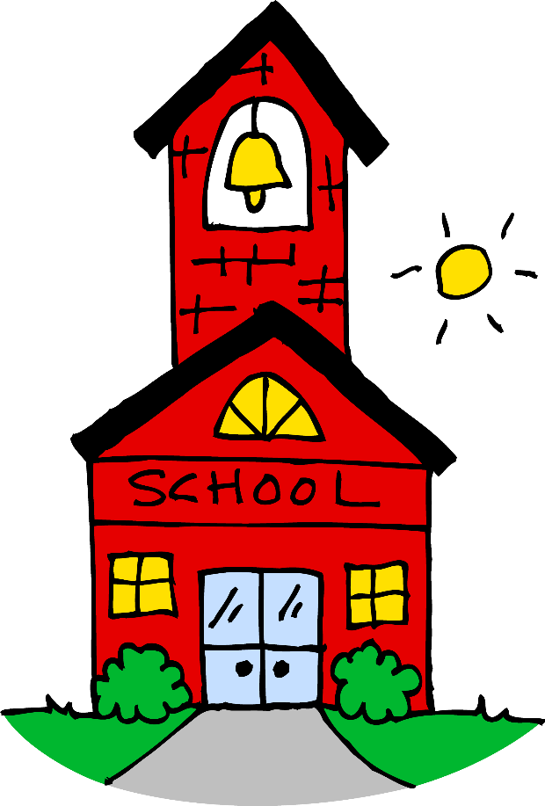
Attending school is an important part of our program and it is essential for your growth and development as a young adult. As a result, your school attendance, behavior, and performance at school will affect your treatment progress and privilege status within the Group Home. If you have any missing assignments or are failing any classes, your privileges may be paused, so that you can spend your time focused on catching up on what needs to be completed. Your case manager will monitor your ongoing academic progress and will review your grades weekly.

School Expectations
- Maintain regular attendance
- Follow up with your teachers after missing classes
- Utilize the transportation services provided by the school district
- Arrive to and depart from school at the designated times
- Keep up on your homework and maintain passing grades
- Utilize study hour and free times to work on homework and study
- Advocate for your needs and ask for help when needed
Earning Reward Bucks
- You can earn $100 reward bucks per week on Sunday mornings, if you have no missing assignments by the end of the week.
- You can earn $100 reward bucks per week on Sunday mornings, if you attended school each day and are passing all of your classes by the end of the week.
Excused and Unexcused School Absences
- Appointments: If you have an appointment scheduled, the team will call the school office and mark you as having an excused absence. Depending on the timing of the appointment, you may be brought to school late, picked up from school early, or excused for the entire day.
- Sick: If you express or are observed to be experiencing signs and symptoms of illness, you will not be expected to go to school. In this situation, the team will call the school office to mark you as having an excused absence. You will then be expected to remain in your bedroom for the following 24 hours. If you express being sick, but it is determined that you are not being truthful, this will be counted as a school refusal. This will be considered an unexcused absence and your privileges will be paused for the remainder of the day.
- Refusal: If you choose to not attend school, this will be counted as an unexcused absence and your privileges will be paused for the remainder of the day. This may include, not being able to go off grounds, use electronics, or spend reward bucks.

SICK POLICY
If you are experiencing signs and symptoms of illness, you will be expected to remain in your bedroom for the following 24 hours. During this time, you will be allowed to come out of your room during meal and snack periods, during medication administration, and to complete your daily hygiene. The purpose of this policy is to encourage you to take time to rest and get better, while helping to not spread the illness to the other individuals in the home or community. While on sick policy, you will also be expected to wear a mask when coming out of your room. While sick, you will be excused from participating in all programming and you will not be expected to complete your daily chores. If you choose to not follow sick policy, your privileges will be paused for the remainder of the day.

If you are experiencing a headache, stomach-ache, or other minor injury, you may ask a team member for an over-the-counter medication (acetaminophen or ibuprofen) to help with your pain. You may also request to lie down and rest for up to an hour and you will be excused from participating in programming. If you continue to require more than an hour of rest time, you may be placed on sick policy. Being placed on sick policy will be determined on a case by case basis depending on symptoms.

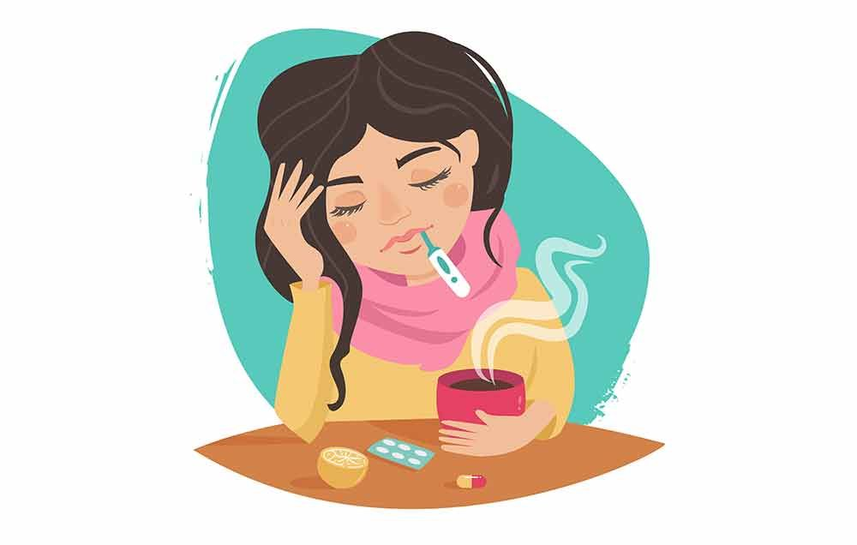
PERSONAL BELONGINGS
Storage Spaces
The following expectations are in place to help protect your belongings. It is your responsibility to keep track of your items. Positive Alternatives is not responsible for stolen or damaged belongings, including valuables and money. We have different locked storage spaces that are available to you, and we encourage that you take advantage of this. Available storage spaces include:
- Bedroom closet: Each bedroom has a closet with the ability to be locked. If you have any concerns about your items being stolen or damaged, you have the option to keep your closet locked when preferred.
- RC Office: The RC office has a shoebox sized storage space available for each youth. This space is designated for controlled items or valuables that you regularly use (ex. pens/pencils, spiral notebooks, money, MP3 players, headphones, makeup items, perfume, etc.).
- Storage Room: This room has a larger amount of space available for you to keep your belongings. This is where all controlled items will automatically be kept. However, you are also able to request to keep other important items in this room as well. The team will be the only individuals allowed to enter this room, so it will be a secured space to keep your important items.
Lost & Found
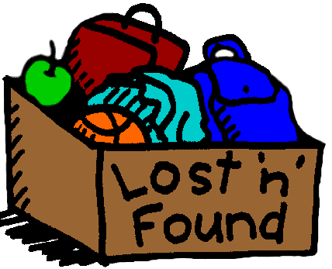
To maintain a clean and decluttered living environment, youth are expected to put away all personal belongings when they are not in use. Additionally, all controlled items should be returned, and other belongings must be put away in your bedroom before transition periods. All items left out during these periods will be placed in the lost and found, which is in the storage room.
To retrieve an item from the lost and found, a youth must complete one verbal positive affirmation about themselves (ex. I am kind, I am strong, I am a good friend, I am a hard worker, etc.). These responsibilities are in place to help build regular practices that allow for keeping a decluttered home and the ability to keep track of one’s belongings. During Saturday room cleans, youth can collect all items from the lost and found, without the requirement of stating positive affirmations.

Controlled Items
All controlled items will be kept in their proper storage spaces. It is your responsibility to keep track of and return all controlled items before transition periods. Not returning controlled items, may result in your privileges being paused. Different controlled items may include:

- Paper clips, tacks, pencil sharpeners, scissors
- Markers, pens, pencils, paint, spiral notebooks
- Backpacks, purses, bags, belts, jewelry

- Hygiene products, makeup, perfume, nail polish
- Razors, nail clippers, tweezers
- Electronics (MP3 players, speakers, headphones, chargers, iPads)

- Candles, incense, sage, lighters
- Household tools (screw drivers, hammers, nails)
- Kitchen utensils (silverware, knives, pizza cutter, can opener)

- Cleaning chemicals, aerosol cans
- Clothing or items that glorify alcohol, drugs, nudity, or violence
- Controlled substances & paraphernalia

SHARING ITEMS & DONATIONS
Sharing Policy
The following expectations are vital to the wellbeing of everyone staying at the group home and the overall dynamics of the house. During your stay here, you are not allowed to buy, borrow, share, or exchange items (including money, food, reward bucks, clothing, and misc. items) with other youth in the home. While it may be a common practice for you to want to share your items and buy things for your friends at the house, this will not be permitted during your stay.
Although you likely have positive intentions behind wanting to help your friends and housemates, the dynamics of the house are everchanging. Everyone will have the opportunity to earn their own money through completing their daily room cleans and chores, and we encourage you to save your money to buy your own items, rather than sharing with a peer. In addition to this, gambling is not a permitted activity during your stay, despite the value of the items that may be in question.
An exception to the sharing policy:
- Youth are able to share items with the household, when engaged in an activity together, that is in a common space, and after being approved by the team. If a youth is willing to share an activity item, this must be shared amongst all members of the house.
- Examples of this exception include:
  - A youth has a card or board game that they want to play with their peers.
  - Art and paint supplies that are being used as a group.
  - A speaker or basketball that are being used outside as a group.
Donating Items
During your stay, you may spend time reevaluating your items and if you would like to keep them or not. If you decide that you have belongings that you no longer want, you have the option to donate them to the house. If you have items that you would like to donate, please communicate this to the team and they will gather these items from you.
You are not allowed to donate items to specific individuals at the house and if you choose to donate your items, they will be available to all youth. Depending on the dynamics of the house and the amount of current donations available, your items may not be available until all current youth are discharged from the program. You will also have the option to donate your items and bring them to a local thrift store, if you prefer to donate to community members.
Needed Items
Everyone is coming to the group home from different situations and experiences that result in people arriving with various amounts of items. If you find yourself in a situation where you do not have many clothing items, please communicate this to the team, as we have different available options for you.

Foster’s Closet: This organization is located in Menomonie and provides an abundance of clothing items that have been donated by community members. We can set up an appointment to visit this location, so that you can shop for and collect needed items at no cost.

Donated Items: We keep all donated items from the team and community members, in the garage. If you are interested in looking through the donations, you must first ask someone from the team. You are also responsible for keeping this area neat and organized after you have gone through it.
Controlled Substance Policy
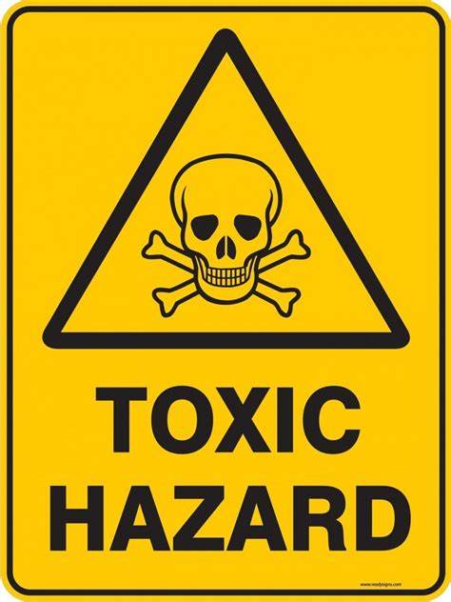
Controlled Substances Include:
  - Tobacco – Cigarettes, Vapes, Chew
  - Alcohol – Including any products used to gain the same effect
  - Illegal Drugs – Including misusing prescription and non-prescription medication
  - Toxic/Hazardous Items – Any product used in an intended way to gain a “high”
Use, Possession, & Suspicion
- Substance use of any kind is not allowed during your placement. This includes at the group home, school, work, visits, as well as, in the community with others.
- Possession of controlled substances and/or related paraphernalia is not allowed.
- Use of substances negatively impacts your physical & mental health and is illegal for youth.
- Possession of controlled substances/paraphernalia will lead to suspicion of use.
- Reports of suspected use made by reliable sources will lead to suspicion of use.
- All privileges for all youth staying at the house will be paused if there is suspicion of substance use at the group home, until the responsible individual(s) have been identified.
  - Suspicion could come from:
    - Physical evidence left behind from these items, including ashes, cigarette butts, empty bottles, used and unused paraphernalia.
    - Smelling smoke or other suspicious odors.
    - Observing physical signs of use and unusual behaviors.
- If you want to make a conscious effort to quit using, the team will support this decision and help you come up with a plan. You may request to see a doctor or a counselor to help with this process.
- If there is suspicion that you are in possession of a controlled item, that may pose as a danger to you or someone else’s safety or treatment, the team may present you with a denial of rights and request to do a search. Searches are conducted to ensure safety of all those in the home.

PHYSICAL BOUNDARIES & RESTRICTED AREAS
Physical Boundaries
Maintaining physical boundaries helps to protect your space and body, your right to not be touched, and your right to privacy. Setting a physical boundary clearly defines that your body and personal space belong to you. The following expectations are in place to promote age-appropriate boundaries, respect for self and others, as well as, to ensure safety, personal responsibility, and the best environment to support treatment progress.

- Do not touch other individuals in the home, this includes both the team and your peers. You must be clearly separated and at an arm’s length away from others at all times.
  - No intimate or sexual activity will be allowed; this includes back rubs, handholding, kissing, hugging, piggyback rides, etc. Intimate and romantic relationships are discouraged and not allowed between peers during your stay at the group home.
  - You are expected to avoid engaging in horseplay, wrestling, and roughhousing.
  - Youth can exchange high fives and fist bumps, if done in an appropriate manner.
  - Only 2 youth are allowed on the couches at a time: 1 youth per cushion. Additionally, youth may not share blankets or lay closely to each other on the floor.
  - Youth are not allowed to sit or lay on another individual’s bed.
- Do not enter other individuals’ rooms or bathrooms; doing so is a violation of that youth’s personal space. Similarly, only one youth is allowed in the following spaces at a time: chill room, activity room, bathroom, and hallway.
- All youth must change their clothes while in their designated bathroom with the door shut and locked. You are not allowed to change your clothes while in your bedroom, due to the possibility of another individual accidentally walking in during this process.
- During transition periods and medication administration, you are expected to stay in your bedroom with your door shut. This maintains the confidentiality of those in the house.
- You are expected to give your peers privacy when they are on the phone.
- Note passing and secretive conversations are not allowed. If you would like to write a letter or card to a peer, please ask a team member to review the content first.
Restricted Areas
Around the house there are different restricted zones that we ask you to not enter. These spaces hold either controlled items or HIPPA related information. Entering these spaces will result in your privileges being paused.
- The RC office is a restricted place that is for the use of team members only. No youth may enter or reach into the office at any time. Additionally, house keys are to only be used by team members. Please do not consider this a lack of trust when you are not allowed to use them.
- The storage room and kitchen pantry are both restricted zones. If you need something out of either location, please talk with a team member about helping you with this.
- Youth are not allowed to enter the basement, unless specifically invited down by a team member. Youth are only allowed in the basement when accompanied by a team member or during an on-grounds family visit. Additionally, your case manager may invite you down to the basement for meetings.
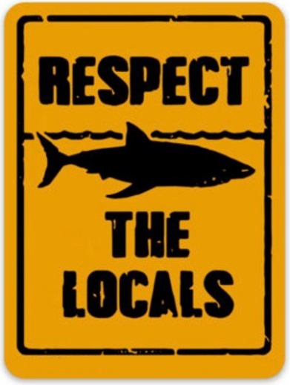
SAFETY & RESPECT
When building healthy relationships with others, respect is a vital ingredient. Respect helps to create a sense of trust, safety, and cooperation. When people feel respected, they're more likely to trust those around them and be open to cooperation. Showing respect also helps to prevent conflict. When people feel respected, they are less likely to feel defensive or threatened, and they're more likely to listen to each other. The following expectations are in place to help promote healthy and respectful relationships that will foster a positive environment and support treatment progress.
- No form of bullying or harassment will be tolerated in the group home.
  - Bullying behaviors can be verbal, physical, or social.
  - If you feel that you are being bullied, harassed, or discriminated against, please communicate this to a trusted adult. We do not tolerate this behavior and your wellbeing and safety are very important to us.
- You are expected to talk to others in a respectful manner and you should not speak to people in a demeaning way. Racist, sexist, or otherwise offensive remarks/jokes will not be tolerated.
- Our words hold power, and we need to learn the appropriate time to speak in different ways. Swearing and the use of inappropriate language will be discouraged, and you will be encouraged to find alternatives ways to express yourself.
- Conversations that glorify negative choices and behaviors are discouraged.
- You are expected to maintain the confidentiality of those staying at PA. This includes not disclosing names or specific information about other youth.
- You are expected to respect the property of both PA and your peers. You will be expected to pay for all damaged property and depending on the damage, law enforcement will be contacted.
Personal Appearance
Part of learning healthy independent living skills is understanding how to dress appropriately depending on the setting and environment that you are in. During your stay at PA, we make it a goal to help you develop your understanding of how you would like to present yourself in different situations. As a team, we believe that it is important to emphasize that this is your space, and we want you to feel both comfortable and safe while here. Below are some general guidelines and expectations to be mindful of when deciding how to present yourself. These expectations are in place to help ensure that both you and the others in the home feel comfortable. Additionally, when changing your clothes, you are expected to do so in the bathroom with the door locked. This is to ensure your own privacy, and so another youth or team member does not accidentally walk in when you are changing.

Youth are expected to:
- Wear pants and a shirt, or the equivalent, at all times (even when sleeping).
- Wear clothing that is opaque and covers both undergarments and private areas.
- Wear properly tailored clothing that fits your body well and in a comfortable manner.
- Not wear clothing that depicts the use of controlled substances.
- Not wear clothing that depicts hate speech targeting other groups.
- Not wear clothing that depicts nudity, sexual acts, or violence.
- During your stay with Positive Alternatives, you are not allowed to get any body piercings or tattoos.
- You are not allowed to get drastic haircuts or dye your hair without first receiving consent from your guardian. Additionally, you must sign the “Hair Dye Contract” to dye your hair in the group home.

SUPERVISION & Run policy
Supervision
- Youth must always be in direct sight or sound supervision of the team. Any time spent away from the group home must be pre-approved by your treatment team.
  - You may gain the opportunity to have unsupervised time by showing treatment progress, including positive choices and behaviors (ex. going on walks, getting a job, spending unsupervised time in the community).
- More than one youth may not be in any room together without a team member present. The exception to this is when you have a roommate.
  - Roommates may only be in their room together during transition periods, medication administration, and sleep hours.
- Youth are expected to ask and inform the team members present about moving from room to room, this includes going to the bathroom or your bedroom.
- All doors must be shut after leaving a room.
- Lights must stay on in commons areas and the dome lights in between youth bedrooms, should never be turned off.
- Youth are not allowed to enter other youth’s rooms or bathrooms at any time.
- Only one youth is allowed in the following spaces at a time: chill room, activity room, bathroom, and hallway.
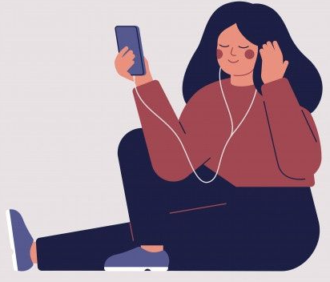
Run Policy
Before
- Our main concern is for your safety. If you choose to leave PA care, we will provide you with the needed belongings to ensure that you are dressed appropriately for the weather.
- The team will try to encourage you to stay at the house and we will try to help you reconsider your options, but we will not stop you from leaving.

During
- The team will continue to supervise until you are out of sight.
- Law enforcement, your social worker, and guardian(s) will be notified about you leaving PA care.

After
- Once you return to the house, a person and belongings search will be conducted. If you do not comply with this search, this will be documented, and a room search will be conducted.
- A UA may be requested by your social worker.

Considering Alternatives
- When you are in a calm state of mind, work with your case manager to create a safety plan for when you feel the urge to leave care. This will help in moments when you cannot verbally express yourself.
- Identify what is making you want to leave PA care, what are your current needs? Communicate this with the team, so that we can help.

YOUTH RIGHTS
As a team we believe that it is important that you understand that you have rights and that there is a process to take if you ever feel like these are being violated in some way. Below is the list of rights that you have during your stay. If at any time you feel that your rights are being violated, please speak with a trusted team member, and complete a Grievance Form (Policy on Next Page). This process will be completed on an iPad and the form will go directly to the Program Director. If your complaint involves the Program Director, it will go to the President/CEO of Positive Alternatives. Our goal is to be able to work with you to make you feel respected, comfortable, and valued. Even if you do not feel a Grievance Form is necessary, please speak with any trusted member of the team about your concerns.
- You have the right to all the same basic rights that all Americans have and are protected by law. Being a youth of Positive Alternatives does not take away these rights.
- You have the right to be treated equally regarding age, religion, race and you have the right not to be singled out for being “different”.
- You have the right to a treatment plan that you understand and meets your individual needs, and you can participate in the process of treatment planning.
- You have the right to receive care and treatment provided by quality staff.
- You have the right to private visits, phone calls and mail with your family and other important people like your social worker and attorney. You have the right to a full explanation if this is restricted.
- You have the right to have the expectations, rules and regulations of Positive Alternatives, Inc explained to you.
- You have the right not to be asked to do unfair work without pay.
- You have the right to a safe, healthy and nice place to live.
- You have the right to privacy, consistent with safe supervision.
- You have the right to make a complaint or file a grievance when you feel your rights are violated.
- You have the right to attend religious services of your choice, consistent with the availability of safe supervision through volunteers or staff.
- You have the right to be protected from cruel, embarrassing, or abusive punishment.
- You have the right to confidentiality. The team is not allowed to share information with others outside of this agency without your guardian’s permission.
- You have the right to prompt, proper and adequate health care.
- You have the right to refuse to be filmed, taped or photographed.
GRIEVANCE POLICY
Positive Alternatives, Inc. supports the protection of clients’ rights as guaranteed by the United States Government for its citizens and specifically as defined by the United States Constitution, Acts of Congress, Chapter 51.61 and Chapter 48.66 of Wisconsin State Statutes, and HSS 3.31 of Wisconsin regulations. The Youth Rights are posted in our facility according to regulations.

In the event that a youth, parent/guardian, legal representative or referring worker wishes to lodge a grievance against Positive Alternatives, Inc., it is requested that the following procedure be used:

1. Inform the Program Director of the intent to file and the nature of the grievance. If the Program Director is unacceptable due to involvement in the grievance, the grievance should be referred to the President/CEO. The Program Director will request and assist, as needed, in getting the grievance documented.

2. The documented grievance will be reviewed by the President/CEO for the action and reply within ten working days.

3. In the event the grievance is not satisfactorily resolved, a written appeal to the Board of Directors can be made. The Board President will respond to the formal appeal within fourteen working days.

If the complaint has not been resolved through this process, with the client or Positive Alternatives, Inc. may file an appeal with the county agency responsible for complaints (Department of Social Services, 51.42/51.437/Unified Board). An alternative would be the Department of Health and Human Services. At any time, a party may choose to take the issue to court. The commencement of a court action will terminate any pending grievance at the same time.

EMERGENCY PLAN
It is important for you to know that there is a plan in place in case of an emergency or natural disaster. As a team, we complete monthly fire and tornado drills to ensure that everyone living in the house knows what to do in case of an emergency. Additionally, there are designated members of the team that focus on ensuring that different safety features, such as the fire alarms and fire extinguishers, are in proper working condition to ensure your safety. Additionally, all members of the team are required to attend trainings to learn and practice fire safety, first aid, and CPR.
To maintain the general safety and security of the house, all entrances will be locked at all times. However, the deadbolts on the front and backdoors should never be locked. In the case of a fire, everyone in the house must be able to exit the building using a single motion when opening the doors; having a deadbolt locked prevents this. Similarly, all exits must be kept clean and decluttered, so that in the case of an emergency, everyone is able to exit the home safely.
- In the event of a fire, all members of the team and youth are to meet across the street from the house, near the fire hydrant.
- In the event of a tornado, all members of the team and youth are to meet in the basement in the furnace/utility room.
- In the event of a natural disaster, where there is damage to the home (tornado, blizzard, flood, fire, power outage, etc.) the team will organize housing and youth care. This includes moving to a designated location with the goal of safety and security for the youth.
